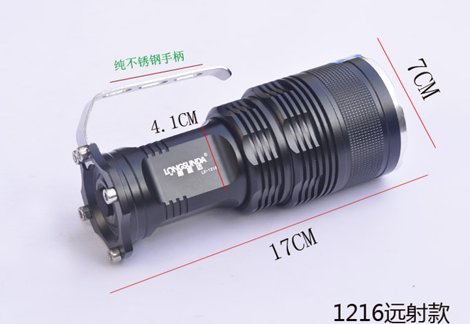
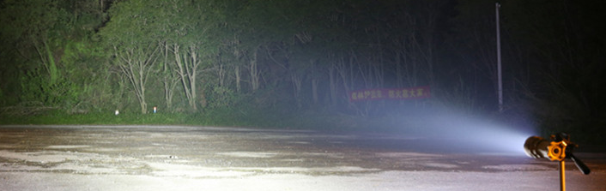
Accessories for LED Flashlight
HS CODE | Product Name | Price | Qty(Pcs) | Amount(US$)
8513101000 | LED flashlight LED手电筒 | $10/pcs | 4 | $40

From:
Company: HangZhou WoRong Technology Co. Ltd
Tel: 86-15967129903
Manager: Vincent Chen
Email: master@civillaser.com

To:
Christopher Caracci
12300 Las Vegs Blvd. So.
Henderson, Nevada 89044
United States
Tel: 702-797-1007

For:
Order No 3939 / Parcel#5

